MAD 1 RESOURCES

- MAD 1 YOUTUBE CHANNEL : (Click below if link doesn't work)
https://youtube.com/@madi6496?feature=shared

- Previous Term Theory Playlist : (Click below if link doesn't work)
https://youtube.com/playlist?list=PLAhdwKzwjRu3Py0Jp4umnOAbhx4TYLERk&feature=shared

- Previous term TA sessions Playlist : (Click Below if link doesn't work)
- https://youtube.com/playlist?list=PLAhdwKzwjRu2-7W8s5t8fUEVw9lhN00Tt&feature=shared

- This term theory Playlist : (Click Below if link doesn't work)
https://youtube.com/playlist?list=PLAhdwKzwjRu2fM8zg-gXrD7Re4J2KZBAI&feature=shared

MAD 1 Lab Assignments:
- Week 2 LA
- Week 3 LA
- Week 4 LA
- Week 5 LA
- Week 6 LA
- Week 7 LA

MAD 1 REVISION SESSIONS:

- Quiz 1 Revision Session
- Quiz 2 Revision Session
- End Term Revision Session Pt 1
- End Term Revision Session Pt 2

PYQS

LEVEL IN DEGREE |  | QUIZ 1 |  | QUIZ 2 |  | END TERM
 |  | 2021-22
DIPLOMA |  | JUNE 5th | IIT M DIPLOMA QUIZ1 QPE1 | MAR 13th | IIT M DIPLOMA QUIZ2 QPC1 | AUG 7th | IIT M END TERM QPB1 | IIT M ENDTERM QPD2
 |  | OCT 21st | IIT M QUIZ DIPLOMA QPC 31 | JULY 10th | IIT M DIPLOMA QUIZ2 QPE1 | APR 3rd | IIT M END TERM AN1 | IIT M ENDTERM FN1
 |  | OCT 10th | IIT M QUIZ EXAM DIPLOMA | OCT 31st | IIT M QUIZ DIPLOMA QPC 31
 |  | OCT 16th | IIT M QUIZ 1 DAD DIPLOMA | NOV 20th | IIT M DAD DIPLOMA AN2 QPD1 | DEC 12th | IIT M ENDTERM QPC1 | IIT M ENDTERM QPH1
 |  | 2023
 |  | FEB 26th | IITM QUIZ EXAM DIPLOMA | APR 02nd | IIT M DIPLOMA AN2 EXAM | APR 30th | IIT M ENDTERM QPD2 S1 | IIT M ENDTERM QPD1 S1
 |  | JUL 16th | IITM QUIZ EXAM DIPLOMA | AUG 6th | IIT M DIPLOMA EXAM | SEPT 3rd | IITM ENDTERM FN | IITM ENDTERM AN
 |  | OCT 29th | IITM QUIZ EXAM DIPLOMA | DEC 3rd | IITM QUIZ EXAM DIPLOMA | DEC 24th | Final Exam QPs
 |  | 2024
 |  | FEB 25th | IITM QUIZ EXAM DIPLOMA | MAR 24th | IITM QUIZ EXAM DIPLOMA | APR 28th | IITM QUIZ EXAM DIPLOMA
 |  | JULY 7th | IITM QUIZ EXAM DIPLOMA | AUG 4th | IITM QUIZ EXAM DIPLOMA | SEPT 1st | FN | AN
 |  | OCT 27th | IITM QUIZ EXAM DIPLOMA | DEC 1st | IITM QUIZ EXAM DIPLOMA | DEC 22nd | FN | AN
 |  | 2025

Quiz 2 Paper Discussions:

- May 2024 Quiz 2 PYQ
- Jan 2024 Quiz 2 PYQ
- Sept 2023 Quiz 2 PYQ
- May 2023 QUIZ 2 PYQ

End Term PYQ Discussions:
- May 2024 ET PYQ
- Jan 2024 ET PYQ
- Sept 2023 ET PYQ

(Please scroll down)

Project resources:
https://discourse.onlinedegree.iitm.ac.in/t/most-awaited-resource-for-mad2-project/98396?u=22f3000877
This link is for mad 2 but his profile has one post for mad 1 as well.

Formula Sheet:

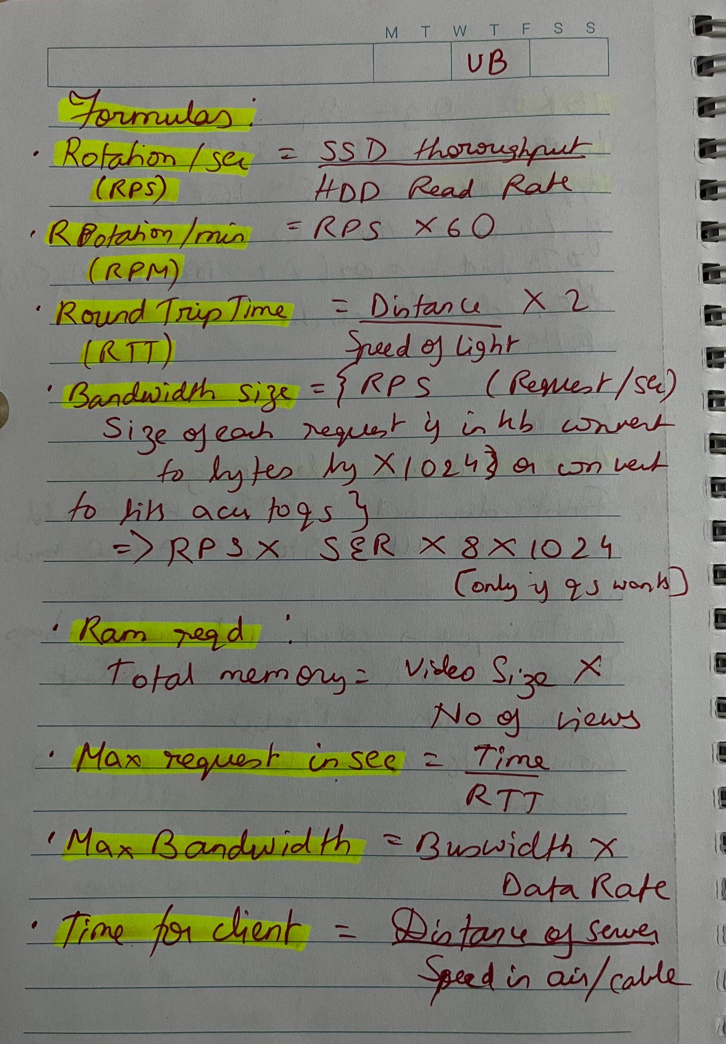

Conversion sheet:

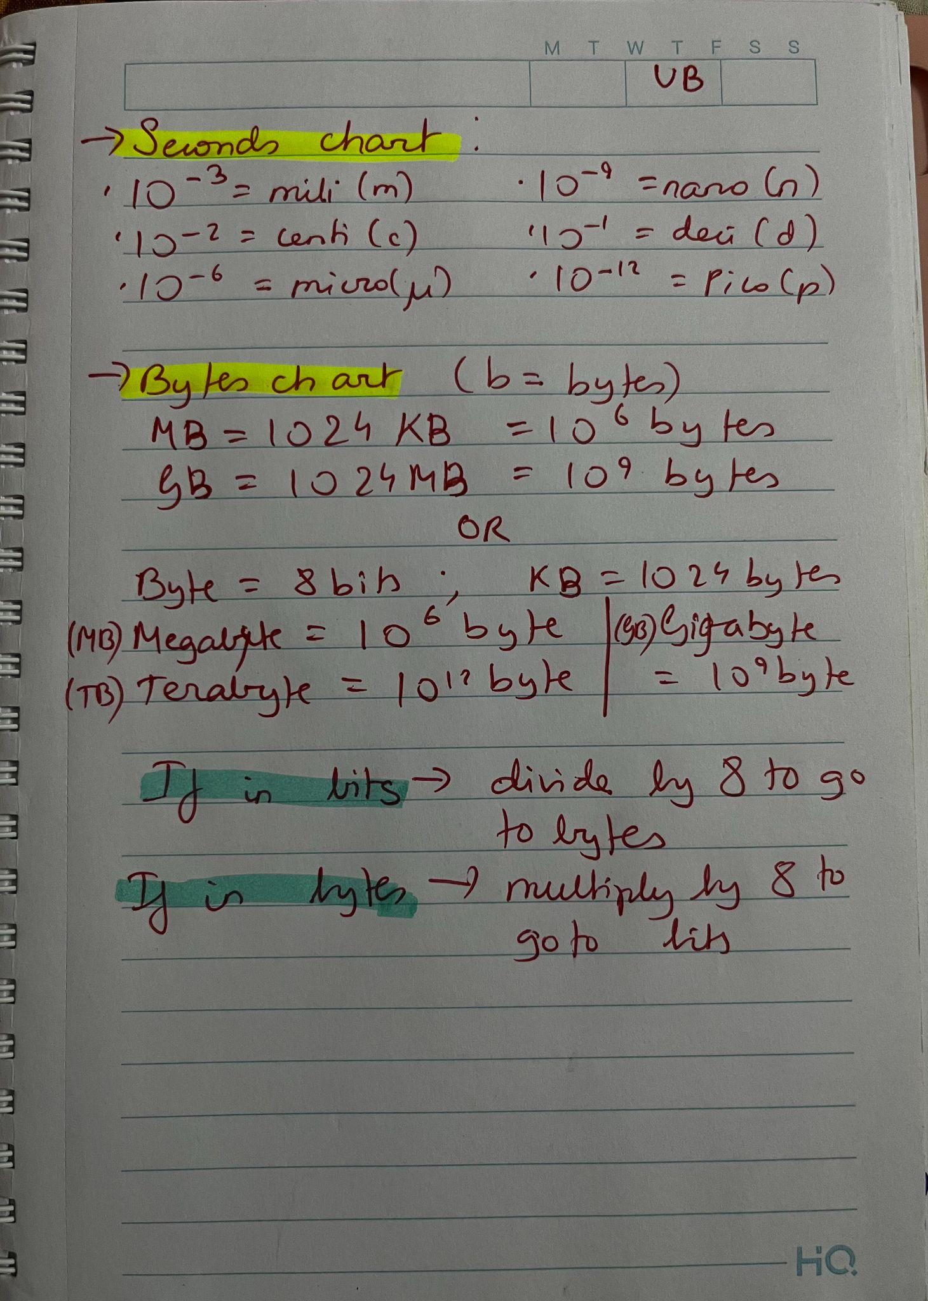

Binary sheet:
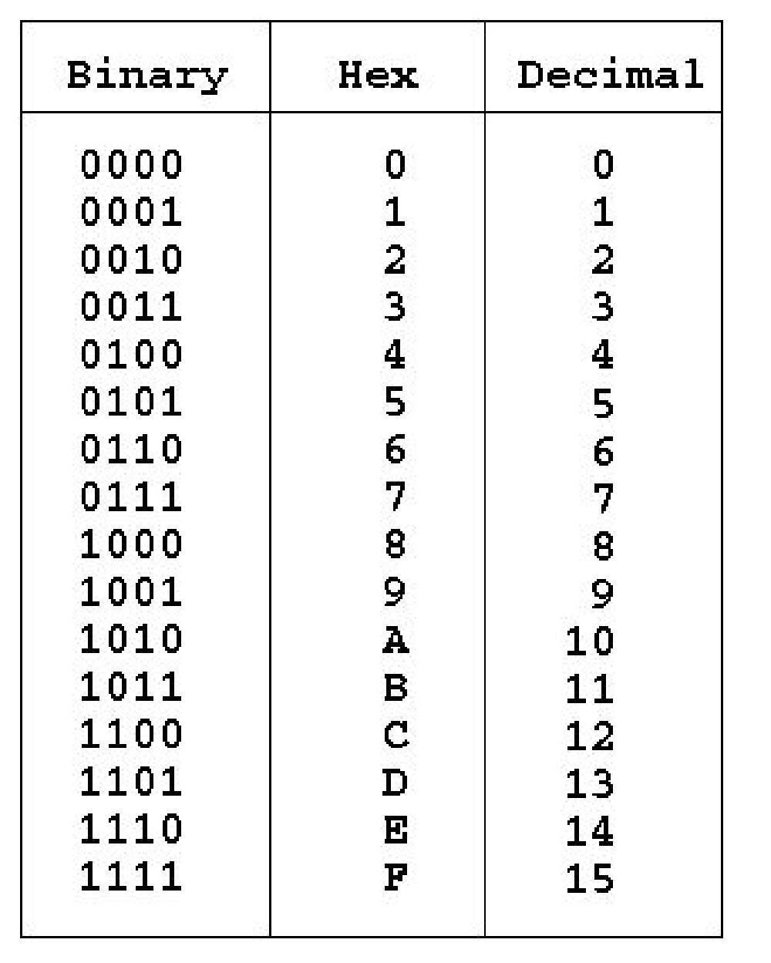

Final note: Hope these resources help you a little bit in your studies.Happy learning :)
Also please reach out to me if there are any errors or any changes that need to be made in the doc in discourse(22f3000877) or via email (22f3000877@ds.study.iitm.ac.in).

